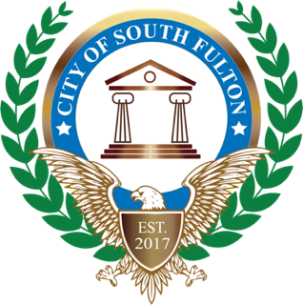
Office of Helen Z. Willis, Councilwoman
City of South Fulton, District 3
5440 Fulton Industrial Boulevard
Atlanta, GA 30336
Contact: LaShandra Little, Legislative Specialist
lashandra.little@cityofsouthfultonga.gov
Phone: (404) 670-9619

FOR IMMEDIATE RELEASE:

District 3 Councilwoman Helen Z. Willis Appointed to Serve on National League of Cities’ Public Safety and Crime Prevention Committee
(CITY OF SOUTH FULTON, GEORGIA, Tuesday, January 12, 2021 -) Councilwoman Helen Willis has been appointed to the National League of Cities (NLC) 2021 Public Safety and Crime Prevention (PSCP) federal advocacy committee.
Councilwoman Willis, was elected to a one-year term and will provide strategic direction and guidance for NLC’s federal advocacy agenda and policy priorities. The appointment was announced by NLC President Kathy Maness, councilmember, Lexington, South Carolina.
“I’m honored to be appointed and given the opportunity to represent City of South Fulton in service to the National League of Cities Public Safety and Crime Prevention federal advocacy committee. The City of South Fulton has over 100 thousand residents. Being the 3rd largest city in Fulton County, Georgia, will benefit tremendously from my appointment to this committee because I will be in the forefront of shaping national policies that impact Public Safety and Crime Prevention locally, said Willis.
“We can’t arrest our way out of crime, so I’m looking forward to working with municipal officials throughout the nation to develop innovative, proactive, and progressive policies that will help local cities combat public safety challenges such as human trafficking, juvenile crime, gun control, and gang-related crimes.”
“As a committee member, Willis will play a key role among a diverse group of local leaders in shaping NLC’s policy positions and advocating on behalf of America’s cities and towns before Congress, with the administration and at home.
“Our federal advocacy committees are the voices of what’s happening on the ground in our communities,” said Kathy Maness, councilmember of Lexington, South Carolina, and President of the National League of Cities (NLC). “I am proud to have Helen Willis join NLC's Public Safety and Crime Prevention Committee on behalf of her residents. Together with a team of local leaders from around the country, we will work to solve the most pressing challenges facing our communities.”
For more information on NLC’s federal advocacy committees, visit: www.nlc.org/advocacy/committees.
For more information on this and other initiatives from Councilwoman Helen Willis office, please contact LaShandra Little at (404) 670-9619, visit the COSF District 3 website www.southfultond3.com, and follow on Social @cosfdistrict3.

# # #
About Councilwoman Helen Willis - Considered one of the “Founders” of the City of South Fulton, Helen Willis and other citizens worked the halls of the Gold Dome for years to push for legislation to create the city. In 2017, Willis was elected to serve on the city’s inaugural City Council, representing District 3 citizens. Her strong record of service, community involvement and “above and beyond” community engagement led to her being unopposed on the ballot. In November 2019, Councilwoman Willis was elected to a full four-year term.

